* **Summarize, for each company, its CEO name, Salary, Vested Stock Awards, and Option Awards for all available years in the filing.**

I have chosen five companies, Navistar, Boein, Costco, Yahoo and Microsoft. They are in different industry categories.

* **Navistar International Corporation** is a manufacturer and marketer of medium and heavy trucks and mid-range diesel engines.

Its DEF 14A filings includes the summary compensation tables from 1991 to 2015.

There are five person worked as CEO in this company, James C. Cotting (1991 ~ 1994), John R. Horne (1995 ~ 2002), Daniel C. Ustian (2003 ~ 2011), Lewis B. Campbell (2012) and Troy A. Clarke (2013 ~ now).

The range of their salary is from $94,203.00 (2012, CEO: Lewis B. Campbell) to $1,238,333.00 (2011, CEO: Daniel C. Ustian).

The range of the Vested Stock Awards is from $0 to $4,990,375.00 (1992, CEO: James C. Cotting). The Stock Award could be $0 or unavailable. In Navistar, there are ten years and three CEOs in some year that the Stock Award is $0.

The range of Option Awards is from $0 to $11,878,341.00 (2013, CEO: John R. Horne). The same thing happened in Option Award. In Navistar, there are six years and three CEOs in some year that the Option Award is $0.

* **The Boeing Company** is an American multinational corporation that designs, manufactures, and sells airplanes, rotorcraft, rockets and satellites.

Its DEF 14A filings includes the summary compensation tables from 1996 to 2015.

There are five person worked as CEO in this company, Philip M. Condit (1996 ~ 2002), Harry C. Stonecipher (2003), James A. Bell (2004), W. James McNerney, Jr. (2005 ~ 2014) and Dennis A. Muilenburg (2015 ~ now).

The range of their salary is from $94,829.00 (1996, CEO: Philip M. Condit) to $2,004,231.00 (2014, CEO: W. James McNerney, Jr.).

The range of the Vested Stock Awards is from $0 (2008, CEO: W. James McNerney, Jr.) to $8,712,295.00 (2006, CEO: W. James McNerney, Jr.).

The range of Option Awards is from $0 to $5,914,440.00 (2008, CEO: W. James McNerney, Jr.). In Boeing, only one CEO, W. James McNerney, Jr. received Option Awards from 2005 to 2013.

* **Price/Costco INC** is an American membership-only warehouse club that provides a wide selection of merchandise.

Its DEF 14A filings includes the summary compensation tables from 1992 to 2015.

There are two person worked as CEO in this company, James D. Sinegal (1992 ~ 2011) and W. Craig Jelinek (2012 ~ now).

The range of their salary is from $300,000.00 (1992, 1993, 1994, CEO: James D. Sinegal) to $699,810.00 (2015, CEO: W. Craig Jelinek).

The range of the Vested Stock Awards is from $0 to $5,322,962.00 (2015, CEO: W. Craig Jelinek). In Costco, the Stock Awards received by the CEO started from 2007.

The range of Option Awards is from $0 to $1,615,544.00 (2007, CEO: James D. Sinegal). Option Award is not available any more since 2010.

* **Yahoo Inc.** is globally known for its Web portal, search engine Yahoo! Search.

Its DEF 14A filings includes the summary compensation tables from 2007 to 2014.

There are four person worked as CEO in this company, Jerry Yang (2007 ~ 2008), Carol Bartz (2009 ~ 2010), Ross B. Levinsohn (2011) and Marissa A. Mayer (2012 ~ now).

The range of their salary is from $1 (2007, 2008, CEO: Jerry Yang) to $1,000,000.00 (2013, 2014, CEO: Marissa A. Mayer).

The range of the Vested Stock Awards is from $0 (2007, 2008, CEO: Jerry Yang) to $35,000,002.00 (2012, CEO: Marissa A. Mayer).

The range of Option Awards is from $0 (2007, 2008, CEO: Jerry Yang) to $29,169,334.00 (2009, CEO: Carol Bartz).

* **Microsoft Corporation** is an American multinational technology company that develops, manufactures, licenses, supports and sells computer software, consumer electronics and personal computers and services.

Its DEF 14A filings includes the summary compensation tables from 2002 to 2015.

There are two person worked as CEO in this company, Steven A. Ballmer (2002 ~ 2013) and Satya Nadella (2014 ~ now).

The range of their salary is from $545,833.00 (2002, CEO: Steven A. Ballmer) to $1,200,000.00 (2015, CEO: Satya Nadella).

The range of the Vested Stock Awards is from $0 to $79,777,109.00 (2014, CEO: Satya Nadella). Only the CEO, Satya Nadella received the Stock Award. It began with 2014.

In Microsoft, there is no Option Awards.

|  |  |  |  |  |  |  |
| --- | --- | --- | --- | --- | --- | --- |
| **Company** | **CEO Salary** | | **CEO Vested Stock Awards** | | **CEO Option Awards** | |
|  | **Min** | **Max** | **Min** | **Max** | **Min** | **Max** |
| **Navistar** | $94,203.00 | $1,238,333.00 | $0.00 | $4,990,375.00 | $0.00 | $11,878,341.00 |
| **Boeing** | $94,829.00 | $2,004,231.00 | $0.00 | $8,712,295.00 | $0.00 | $5,914,440.00 |
| **Costco** | $300,000.00 | $699,810.00 | $0.00 | $5,322,962.00 | $0.00 | $1,615,544.00 |
| **Yahoo** | $1.00 | $1,000,000.00 | $0.00 | $35,000,002.00 | $0.00 | $29,169,334.00 |
| **Microsoft** | $545,833.00 | $1,200,000.00 | $0.00 | $79,777,109.00 | $0.00 | $0.00 |

Comparing these five company, the smallest number in CEO salary is $1 from Yahoo. The largest number in CEO salary is $2,004,231.00 from Boeing. The smallest number in CEO Vested Stock Awards is $0. The largest number in CEO Vested Stock Awards is $79,777,109.00 from Microsoft. The smallest number in CEO Option Awards is $0. The largest number in CEO Option Awards is $29,169,334.00 from Yahoo.

* **Determine total vested stock ownership of the CEO and salary trend for all available years in the filing.**

|  |  |  |  |  |
| --- | --- | --- | --- | --- |
| **Total Vested Stock Ownership of Navistar Each CEO ($)** | **Total Vested Stock Ownership of Boeing Each CEO ($)** | **Total Vested Stock Ownership of Costco Each CEO ($)** | **Total Vested Stock Ownership of Yahoo Each CEO ($)** | **Total Vested Stock Ownership of Microsoft Each CEO ($)** |
| $0.00 | $190,473.00 | $10,247,122.00 | $0.00 | $0.00 |
| $156,981.00 | $491,400.00 | $18,504,456.00 | $7,728,320.00 | $92,538,372.00 |
| $1,333,352.00 | $5,105,064.00 |  | $19,601,717.00 |  |
| $6,235,125.00 | $7,185,929.00 |  | $55,064,673.00 |  |
| $8,637,019.00 | $39,511,518.00 |  |  |  |
|  |  |  |  |  |

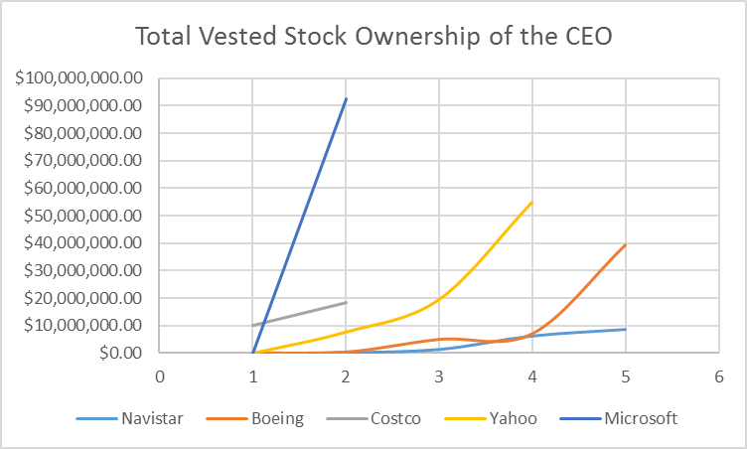

As we see, the CEO of high-tech enterprises received the most Vested Stocks. The highest number is the CEO of Microsoft, Satya Nadella.

|  |  |  |  |  |  |
| --- | --- | --- | --- | --- | --- |
| **Year** | **Navistar CEO's Annual Salary($)** | **Boein CEO's Annual Salary($)** | **Costc CEO's Annual Salary($)** | **Yahoo CEO's Annual Salary($)** | **Microsoft CEO's Annual Salary($)** |
| 1991 | $450,000.00 |  |  |  |  |
| 1992 | $450,000.00 |  | $300,000.00 |  |  |
| 1993 | $450,000.00 |  | $300,000.00 |  |  |
| 1994 | $491,250.00 |  | $300,000.00 |  |  |
| 1995 | $544,166.00 |  | $305,769.00 |  |  |
| 1996 | $650,000.00 | $94,829.00 | $300,000.00 |  |  |
| 1997 | $650,000.00 | $884,675.00 | $300,000.00 |  |  |
| 1998 | $716,667.00 | $998,896.00 | $332,692.00 |  |  |
| 1999 | $833,333.00 | $1,093,079.00 | $350,000.00 |  |  |
| 2000 | $975,000.00 | $1,359,231.00 | $356,731.00 |  |  |
| 2001 | $1,083,333.00 | $1,479,231.00 | $350,000.00 |  |  |
| 2002 | $1,183,333.00 | $1,547,308.00 | $350,000.00 |  | $545,833.00 |
| 2003 | $741,667.00 | $109,615.00 | $350,000.00 |  | $550,000.00 |
| 2004 | $933,333.00 | $596,154.00 | $350,000.00 |  | $591,667.00 |
| 2005 | $993,333.00 | $841,346.00 | $350,000.00 |  | $600,000.00 |
| 2006 | $1,104,167.00 | $1,750,000.00 | $350,000.00 |  | $616,667.00 |
| 2007 | $1,125,000.00 | $1,800,077.00 | $350,000.00 | $1.00 | $620,000.00 |
| 2008 | $1,170,833.00 | $1,915,288.00 | $350,000.00 | $1.00 | $640,833.00 |
| 2009 | $1,180,000.00 | $1,930,000.00 | $350,000.00 | $969,872.00 | $665,833.00 |
| 2010 | $1,180,000.00 | $1,930,000.00 | $350,000.00 | $1,000,000.00 | $670,000.00 |
| 2011 | $1,238,333.00 | $1,930,000.00 | $350,000.00 | $700,000.00 | $682,500.00 |
| 2012 | $94,203.00 | $1,930,000.00 | $662,500.00 | $454,862.00 | $685,000.00 |
| 2013 | $843,182.00 | $1,930,000.00 | $650,000.00 | $1,000,000.00 | $697,500.00 |
| 2014 | $900,000.00 | $2,004,231.00 | $650,000.00 | $1,000,000.00 | $918,917.00 |
| 2015 | $900,000.00 | $1,354,269.00 | $699,810.00 |  | $1,200,000.00 |

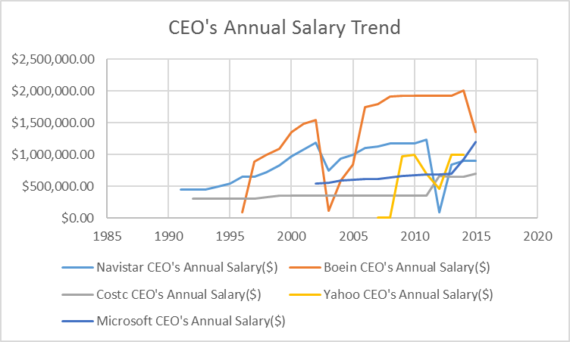

As we see, the CEO salary of Boeing show the highest number. The CEO salary of Yahoo show the smallest number. The CEO salary of Costco has the almost number for 20 years. The CEO salary of Costco and Microsoft increase or keep the almost number. The CEO salary of Navistar, Boein and Yahoo increase or decrease sometimes. Through it, we will know these three companies earned profits or lost profits in different year.

Assuming the last column in the summary compensation table, total compensation is the CEO annual compensation, we can get the following CEO's Annual Compensation Table.

|  |  |  |  |  |  |
| --- | --- | --- | --- | --- | --- |
| **Year** | **Navistar CEO's Annual Compensation ($)** | **Boein CEO's Annual Compensation ($)** | **Costc CEO's Annual Compensation ($)** | **Yahoo CEO's Annual Compensation ($)** | **Microsoft CEO's Annual Compensation ($)** |
| 1991 | $504,315.00 |  |  |  |  |
| 1992 | $498,100.00 |  | $506,279.00 |  |  |
| 1993 | $483,852.00 |  | $353,625.00 |  |  |
| 1994 | $805,371.00 |  | $329,895.00 |  |  |
| 1995 | $1,791,868.00 |  | $372,669.00 |  |  |
| 1996 | $726,998.00 | $1,200,488.00 | $467,150.00 |  |  |
| 1997 | $1,668,268.00 | $1,724,573.00 | $766,836.00 |  |  |
| 1998 | $1,700,801.00 | $1,272,807.00 | $649,922.00 |  |  |
| 1999 | $2,694,833.00 | $4,511,692.00 | $669,045.00 |  |  |
| 2000 | $6,332,503.00 | $18,697,991.00 | $701,066.00 |  |  |
| 2001 | $1,338,708.00 | $4,037,035.00 | $529,664.00 |  |  |
| 2002 | $1,634,780.00 | $3,877,955.00 | $523,756.00 |  | $758,810.00 |
| 2003 | $962,353.00 | $1,086,615.00 | $525,460.00 |  | $871,114.00 |
| 2004 | $3,082,004.00 | $2,063,482.00 | $728,016.00 |  | $910,604.00 |
| 2005 | $7,657,500.00 | $34,254.00 | $647,971.00 |  | $1,009,073.00 |
| 2006 | $3,604,000.00 | $20,555,734.00 | $454,629.00 |  | $976,149.00 |
| 2007 | $2,233,855.00 | $18,997,099.00 | $2,986,357.00 | $1.00 | $1,279,821.00 |
| 2008 | $6,642,747.00 | $16,626,254.00 | $4,913,008.00 | $1.00 | $1,350,834.00 |
| 2009 | $8,181,126.00 | $19,443,472.00 | $3,353,120.00 | $47,229,273.00 | $1,276,627.00 |
| 2010 | $10,382,469.00 | $19,740,023.00 | $3,529,434.00 | $11,946,834.00 | $1,351,121.00 |
| 2011 | $15,167,755.00 | $22,958,313.00 | $2,191,159.00 | $11,988,199.00 | $1,376,915.00 |
| 2012 | $5,767,580.00 | $27,484,138.00 | $4,810,773.00 | $36,615,404.00 | $1,318,128.00 |
| 2013 | $14,527,858.00 | $23,263,562.00 | $5,385,475.00 | $24,935,712.00 | $1,261,218.00 |
| 2014 | $5,363,219.00 | $28,861,920.00 | $5,622,927.00 | $42,083,508.00 | $84,308,755.00 |
| 2015 | $2,082,651.00 | $13,226,333.00 | $6,342,124.00 |  | $18,294,270.00 |

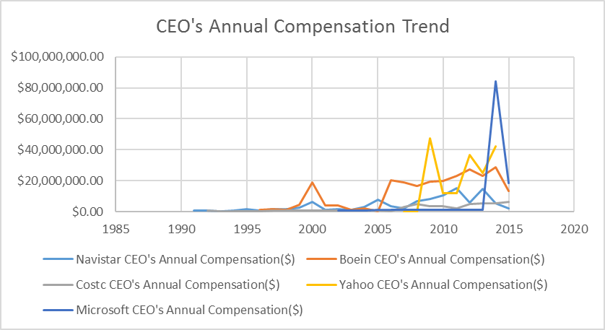

After adding stock awards and other staff, the CEO compensation of Microsoft show the highest number. The CEO compensation of Costco show the smallest number.

* **Describe (in numbered steps) how to automate the above task in SAS or R.**

The steps to automate the task in SAS or R:

1. Read the file
2. Using some key words, such as Summary Compensation Table to determine the range of the data and put the data into a new file which is like a smaller unstructured database
3. Using pattern matching with regular expressions to get different information and form a table
4. Clean the data in the table. For example, convert the format and replace the null value to 0.
5. Do relative calculation.
6. Sorting or graph the results.

Appendix (There are 9 sheets in the excel file):

1. CEO's Annual Stock Award Table
2. CEO's Total Vested Stock Table
3. CEO's Annual Salary Table
4. CEO's Annual Compensation Table
5. Navistar Summary Compensation Table
6. Boeing Summary Compensation Table
7. Costco Summary Compensation Table
8. Yahoo Summary Compensation Table
9. Microsoft Summary Compensation Table